Media homework – Film posters

Denotations and connotations: From what we can see, we can simply see a young girl, looks like a teenager, laying down on a bed of roses. She is naked, but the red roses cover up her most revealing areas. She has a seductive facial expression which could make the audience think she’s a young girl who likes to please and impress the other gender. The fact that she’s laying on a bed of red roses connotes the fact that she may be looking for love. Red connotes a range of feelings and emotions for example desire, passion, lust and love, but on the other hand it connotes danger, aggression and violence. This contrast in meanings show that she may be looking for a lustful relationship, but it may be full of danger and aggression as it won’t be true love. The fact that nothing on her body is being revealed, but is being hidden by the roses, may connote that she is too young to be in relationships, she’s is not mature enough to understand the depth of them therefore needs to be covered up to protect her innocence and youth. Moving away from the main picture, when analysing the title, you can see that the word “beauty” is in bold. This could be because no matter who you are, you will always look for beauty within a person, no matter if it’s on the outside or the inside, so the boldness of the word can show that beauty is important no matter what; and in this movie, it’s clear that beauty plays a very important part.
How are the characters presented: In this film poster, the girl is presented as young and potentially vulnerable, as she is lying down on the bed of rose petals covering up in her most important parts. This presents her as vulnerable as it makes it seem as if she needs protection from love; or possible men.
What do you expect to happen: By looking at this poster, I can tell there will be some sort of romance or relationship throughout, due to the presence of rose petals. Due to roses connoting not only love, but also lust, I can expect that the relationship may be full of lustful desires.
What features does the poster have: The poster features a young girl lying on a bed of rose petals. It also features the actor’s names on the top of the poster with the title of the film at the bottom. It also has a tagline which says “..Look closer”

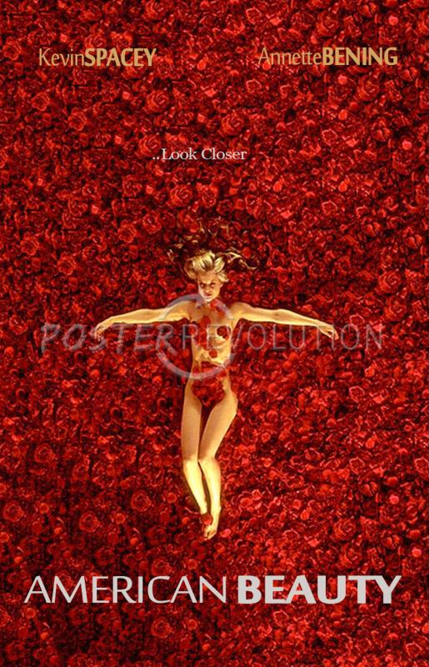
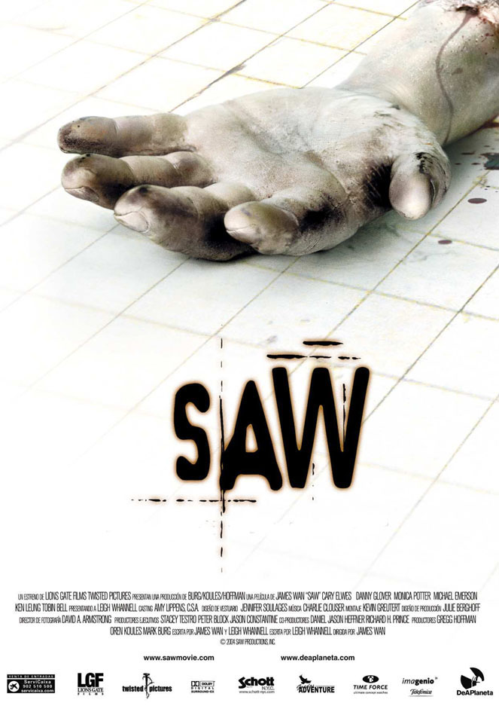
Denotations and connotations: By looking at this poster it is clear to see there is a hand lying on a tiled floor. The hand is clearly pale in colour meaning its most probably the hand of a dead person. The hand is lying there, alone with nothing around showing that possibly the person could of died a very lonely death. By having a dead hand placed on what looks like a normal titled kitchen or bathroom floor emphasises how abstract and strange the situation is by placing an average, everyday thing net to a not so ordinary thing (the dead hand). The white background in the poster contradicts the genre of the movie. White represents purity, goodness and innocence, and the fact that its then got a dead hand on the white tiles as it drips blood could represent that the person which may have killed this said person, may have been pure and good, but had a good and fair reason to kill him; thus showing us that no matter how pure a person is, everyone is capable of some evil. Also, moving away from the main picture, when looking at the title you can see the letters gradually get bigger, and this can connote the fact that as the movie progresses, the intensity and tenses increase and therefore gradually gets scarier.
How are the characters presented: In this poster, there aren’t really any characters presented. The only sign of existence in this movie is the dead hand on the floor. This therefore means that there must be a character who is a killer who must be very powerful; there then must be the victims who are weak compared to killer who end up dying in the movie.
What do you expect to happen: Due to this poster being gory and graphic, I expect there to be some death throughout the movie. It is clear that there is death as there is a dead hand on the floor, and there is blood. The title has also been designed to look like blood which shows there must be violence and death throughout.
What features does the poster have: The poster has a title at the bottom in big bold letters. It also has many institutional logos at the bottom along with the credits of those who helped with the movie. It then just contains the main picture of the poster which is used to show what the main movie is about.

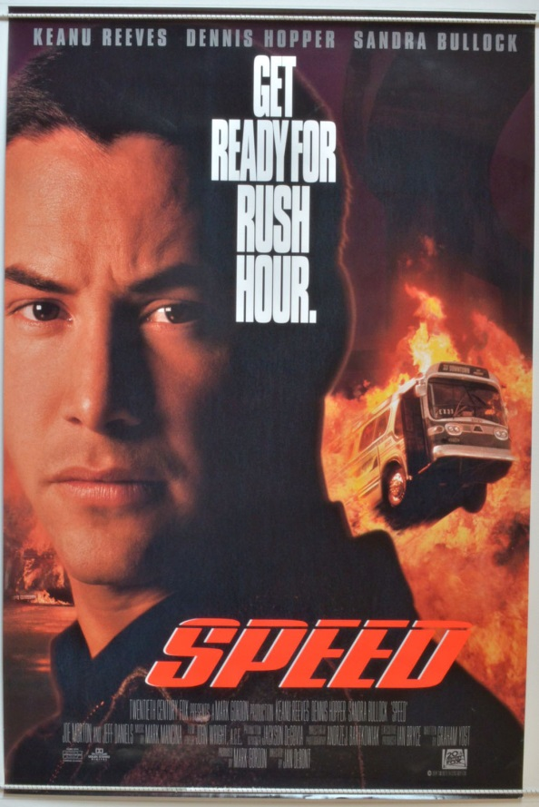
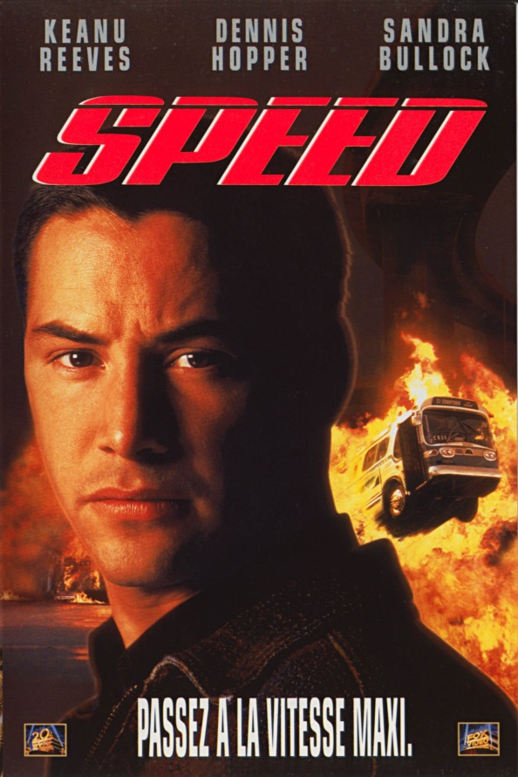
Denotations and connotations: In this film poster the actor is right at the front of the poster with fire and a bus driving through it in the background. The word speed then goes across his head. The fact that the actor is right at the front of the poster shows his authority in the movie. He is clearly the main character, and since he is in front of the fire, which connotes danger and pain, that must show that he is the one who is able to stop the fire and overcome it all. The bus driving through the fire is still intact therefore showing that even though it’s been through damage, something or someone was able to replenish the damage showing that the guy at the front (main actor – Keanu Reeves) was able to be heroin and save the day. The title has been written in italic to not only emphasis the fact the movie is called speed so means the movie must be about a vehicle driving fast, but it also emphasises the fast pace of this movie as it must be an action movie.
How are the characters presented: In this movie poster, the main character is presented as heroic and brave. He is standing in front of the fire showing that he must be able to defeat whatever created or started it.
What do you expect to happen: Due to the look of this poster I expect it to be a fast pace action movie. I expect there to be violence and danger due to the fire present in the background but not only because of that, but also because of Keanu Reeves’ facial expression. He is clearly not happy by something as he looks angry which could be because of someone, which is what could cause the violence.
What features does the poster have: The poster consists of the title in big bold letters, the main actor right at the front, the actor’s names at the top of the poster. It was has action shots happening in the background, and has the tagline which is “get ready for rush hour.” In then also features some institutional logos at the bottom.

