Proposal for the movie ‘Scarlett’
How will the film belong to the horror genre?
Location
The location of the film will initiate in a high school, however, will also locate occasionally in an abandoned building.
Sound
During the film, there will be a range of sounds throughout. This is including the screaming of some characters, scary music to increase the fear among the audience, blood spilling from the death of a character and phone calls.
Characters
There will be characters that will be isolated from the rest of society. These characters will be Lauryn and Scarlett. There will be a mentally disturbed killer who will be Scarlett, an inquisitive female protagonist who will be Lauryn and a mean wealthy girl called Brittney.
Costumes
Lauryn will be dressed in smart casual clothing, it’ll also be a dull colour scheme to emphasise the dullness of her life and the fact that she gets abused at home. Scarlett will be wearing dark clothing to portray her evil characteristics and the fact that she’s the killer. Lastly, Brittney will be wearing expensive clothing to show she’s a wealthy character.
Lighting
The lighting with be dark to make the audience fear about what might happen. It’ll also be mysterious/eerie, again, to allow to audience to fear the unknown. Not only this but there will be shadows showing that it’s a dark setting, and lastly dusk.
Different camera angles/shots
There will be extreme close ups to allow intimacy to be accomplished and so the audience feels close to the characters and feels the intensity of the scene. There will be long shots to emphasise the isolation of Lauryn and Scarlett as you are able to see the surrounding in a long shot and infer that there is no one around whilst they are there. There will also be mid shots so you are able to see the hand gestures of the characters like Brittney when she is being killed; so you can infer that she is fearful of the situation. There will also be eye line shots as this is a neutral shot, so it makes the shot have no dramatic power meaning the audience are supposedly fooled into thinking everything is okay, which in turn makes it more dramatic when something does actually happen. This use of eye level shots also makes the scene a bit more personable, so the audience are automatically made to bond with this character and create a connection. Not only this, but the movie will also consist of POV shots to allow the audience feel what the character is feeling, panning shots, hand held shots, slow movement shots, and zoom shots.
Colour
- black, white, red, grey, (reduced palette)
Editing
- Timing of shots will be the most important aspect (these shots will create suspense making the audience want to watch more)
Target Audience
Age rating 15. This target audience will be the most successful market as the majority of teen horror films are aimed at ages 15-18. Aiming the film at this age group will mean that the film will have an existing fan base who will think that it is similar enough to other successful horrors for them to potentially enjoy it.
Not only that, but teenagers can possibly relate to the character's lives: they can understand what teenage life is about and how social media can be a big part of their lives. There could be a few teenagers that could relate their life. For example, some teenagers may experience domestic abuse at home.
My group and I believe that the audience would enjoy the film: they would be intrigued by the narrative, how there are girls or possibly boys who are experiencing some bullying in their school life.
Introducing the narrative
-Lauryn started her new school: gives the audience an insight of who the protagonist is and what her life was like.
-Main character meets the antagonist (Scarlett) who becomes a close friend.
-Lauryn and Scarlett start to talk about the girls who make their life a living hell and at this point, Scarlett starts to plan the murder of Britney (one of the bullies): very important scene (this would be the catalyst event)
-Lauryn finds out that Brittney is murdered: realises that Scarlett murdered her.
-Scarlett goes 'missing' and Lauryn decides to investigate Scarlett's next victim.
-Lauryn finds Scarlett in an abandoned office building planning her next kill.
-The location is where the movie will be set and it can help the audience to understand who the characters are and this will be the main location where most of the narrative will take place
Props
-For the murders, the main weapon of choice will be a knife which makes the deaths seem more intimate like when Scarlett kills Brittney.
-Phones will be an important prop because most teenagers will use their phones for day to day lives and they are dependent on them for finding out new things using social media.
-School equipment would allow the audience to know that the characters still in education- demographic can relate themselves to the characters.
Budget
-Examples of thriller horror movie budgets:
The Wolfman - £105,000,000
Shutter Island - £56,000,000
Sleepy Hollow - £49,000,000
-These films are examples of thriller horror films with their movie budget. A big risk for having an enormous budget is where the film production companies would make that money back when the film is released to the public. For our film, we haven't come to conclusion for an exact budget for our film because we still need to have auditions for casting but we have a rough idea that the film would cost £1mn to £5mn.
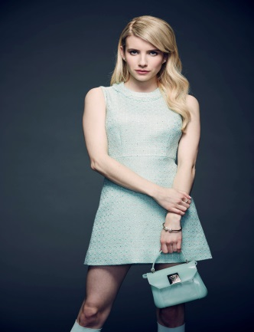
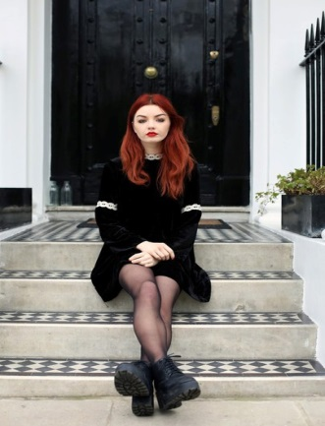
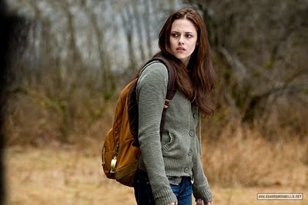
Characters
-These pictures are what the characters would look like in the film.

Lauryn- Finds it hard to socialise, tries to hide the truth about her and that she is a victim to domestic abuse. She first felt that starting a new school would be a scapegoat however it only gets worse for her
Scarlett- Like Lauryn, she finds it hard to socialise among other people. She is considered to be the outcast throughout the whole school. She gets bullied by the other girls in school. Scarlett starts to become obsessed with a thought she had one day and it starts to become out of hand.
Brittney- Stereotypical rich, white woman: she tends to show off that she is popular among the school and that she has a lot of money. She is one of the girls that pick on Lauryn and Scarlett and is the first girl to be murdered.
Sound
In this movie, we will be taking sounds seriously. We believe that this will make the film scarier and build up suspense. It will make the situations engaging for the audience to watch.

